Case 6-Afr-Burkina Faso-Mask-Bwa-Duho (Hawk)-Wood-Kaolin-Ochre-first half of 20th c

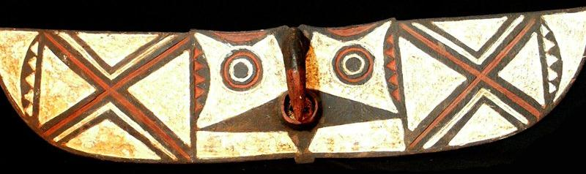 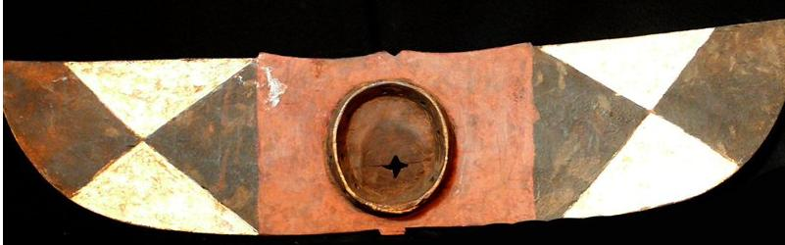

Case No.:

Accession Number:

Formal Label:

**Display Description:**

This wide headdress transforms the dancer into a supernatural hawk-being. They were used by the Do society at dances to promote fertility of the fields and at funerals of Do members. The geometric designs have meanings. The white and black chevron pattern symbolizes the separation of light from dark, good from evil and female from male. As the dancer turns from side to side while moving forward as though in flight, the hawk mask gives a spectacular performance.

LC Classification: NK1087

Date or Time Horizon: First half 20th century

Geographical Area: Dossi, Burkina Faso

Map:

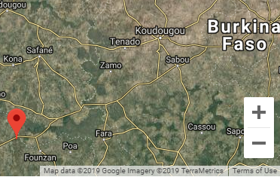

GPS Coordinates: 11°31'00.0"N 3°24'00.0"W

Cultural Affiliation: Kambi clan in Dossi

Medium: wood, red white and black pigments

**Dimensions**: 40.15 inches x 7.87 inches  
**Weight:** 3.06 pounds

**Provenance**: Dossi, Burkina Faso

**Condition: original**

**Discussion:**

The **Bwa** (**Bwaba**, plural, or **Bobo-Wule**, Bobo-Oule, "Red Bobo", perhaps because of their use of red ochre used in applying body symbols, since two other BWA peoples have epithets that denote the use of black pigment and tattooing to distinguish themselves. are an ethnic group indigenous to central and southeastern Burkina Faso, between Mali's Bani River and the Mouhoun River (Black Volta), with a population of approximately 300,000. The Bwa (Bobo-Oule) are a Gur people, speaking mutually unintelligible [Gur languages](https://en.wikipedia.org/wiki/Bwa_languages), which suggests a very ancient language lineage.[[1]](#footnote-2)

They are known for their use of masks, made from leaves or wood, used in ceremonial dances.

Early European explorers to the area called the Bwa "Bobo", confusing them with their neighbours the [Bobo people](http://en.wikipedia.org/wiki/Bobo_people).[[2]](http://en.wikipedia.org/wiki/Bwa_people" \l "cite_note-CDR50-2) Although the two groups share religion and culture, they are ethnically distinct.[[4]](http://en.wikipedia.org/wiki/Bwa_people" \l "cite_note-ALA2-4) The confusion led to alternative names for the Bwa including Bobo Oule, or Eastern Bobo.[[8]](http://en.wikipedia.org/wiki/Bwa_people" \l "cite_note-8) In Jula, Bobo Oule means "Red Bobo". This distinguishes the Bwa from the Bobo who are called the "Black Bobo".[[4]](http://en.wikipedia.org/wiki/Bwa_people" \l "cite_note-ALA2-4) The southern Bwa became known by their neighbors as *Nieniegue* meaning "scarred Bwa" as a result of the tradition of [scarification](http://en.wikipedia.org/wiki/Scarification) of their faces and bodies.[[2]](http://en.wikipedia.org/wiki/Bwa_people" \l "cite_note-CDR50-2) This practice is no longer commonplace and so the term is also in decline.[[2]](http://en.wikipedia.org/wiki/Bwa_people" \l "cite_note-CDR50-2)

## History

In the 18th century, Bwa lands were occupied by the [Bamana](http://en.wikipedia.org/wiki/Bambara_people) empire who made the Bwa pay taxes.[[1]](http://en.wikipedia.org/wiki/Bwa_people" \l "cite_note-ALA-1) The places left unconquered were raided by the Bamana, which led to a weakening of the Bwa social and political systems.[[3]](http://en.wikipedia.org/wiki/Bwa_people" \l "cite_note-FAA-3) In the 19th century, the Bamana declined and the area was dominated by the [Fulani](http://en.wikipedia.org/wiki/Fula_people) who raided and enslaved the Bwa and stole their [livestock](http://en.wikipedia.org/wiki/Livestock).[[2]](http://en.wikipedia.org/wiki/Bwa_people" \l "cite_note-CDR50-2)[[3]](http://en.wikipedia.org/wiki/Bwa_people" \l "cite_note-FAA-3) The end of the 19th century brought French mercenaries who used the Fulani to help control the area.[[1]](http://en.wikipedia.org/wiki/Bwa_people" \l "cite_note-ALA-1) The Bwa traditions of storing crops for use in lean years were undermined by the crippling taxation systems of the French and they suffered further from [famine](http://en.wikipedia.org/wiki/Famine) from 1911–1913.[[3]](http://en.wikipedia.org/wiki/Bwa_people" \l "cite_note-FAA-3)[[4]](http://en.wikipedia.org/wiki/Bwa_people" \l "cite_note-ALA2-4) The French demanded military recruits from the Bwa and in 1915, the Bwa revolted.[[1]](http://en.wikipedia.org/wiki/Bwa_people" \l "cite_note-ALA-1)[[3]](http://en.wikipedia.org/wiki/Bwa_people" \l "cite_note-FAA-3), starting the [Volta-Bani War](http://en.wikipedia.org/wiki/Volta-Bani_War). This war lasted about a year[[5]](http://en.wikipedia.org/wiki/Bwa_people" \l "cite_note-La_guerre_coloniale-5) and ended with the destruction of many Bwa villages.[[4]](http://en.wikipedia.org/wiki/Bwa_people" \l "cite_note-ALA2-4)

## Distribution

The Bwa live in central Burkina Faso and south-east Mali, between Mali's [Bani River](http://en.wikipedia.org/wiki/Bani_River) and the Mouhoun River ([Black Volta](http://en.wikipedia.org/wiki/Black_Volta)) in Burkina Faso.[[2]](http://en.wikipedia.org/wiki/Bwa_people" \l "cite_note-CDR50-2) Their total population is approximately 300, 000.[[1]](http://en.wikipedia.org/wiki/Bwa_people" \l "cite_note-ALA-1) The major towns occupied by the Bwa are [Houndé](http://en.wikipedia.org/wiki/Houndé), [Boni](http://en.wikipedia.org/wiki/Boni), [Bagassi](http://en.wikipedia.org/wiki/Bagassi), [Dossi](http://en.wikipedia.org/wiki/Dossi) and [Pa](http://en.wikipedia.org/wiki/Pa,_Burkina_Faso).[[2]](http://en.wikipedia.org/wiki/Bwa_people" \l "cite_note-CDR50-2)

## Society and politics

Like many of their neighbours, the Bwa are predominantly farmers, their main [cash crop](http://en.wikipedia.org/wiki/Cash_crop) being [cotton](http://en.wikipedia.org/wiki/Cotton). They also farm [millet](http://en.wikipedia.org/wiki/Millet), [rice](http://en.wikipedia.org/wiki/Rice), [sorghum](http://en.wikipedia.org/wiki/Sorghum), [yams](http://en.wikipedia.org/wiki/Yam_(vegetable)), and [peanuts](http://en.wikipedia.org/wiki/Peanut).[[1]](http://en.wikipedia.org/wiki/Bwa_people" \l "cite_note-ALA-1) Bwa villages are autonomous and they do not recognise any outside political authority. They are led by a council of male [elders](http://en.wikipedia.org/wiki/Elder_(administrative_title)) who make all the major decisions.[[1]](http://en.wikipedia.org/wiki/Bwa_people" \l "cite_note-ALA-1) Villages are structured with a cluster of mud walled buildings around a central space where livestock are guarded at night.[[3]](http://en.wikipedia.org/wiki/Bwa_people" \l "cite_note-FAA-3)

## Culture

### Language

The Bwa speak [Buamu](http://en.wikipedia.org/wiki/Buamu_language), a [central Gur](http://en.wikipedia.org/wiki/Central_Gur_languages) language of the [Niger–Congo family](http://en.wikipedia.org/wiki/Niger–Congo_languages).[[6]](http://en.wikipedia.org/wiki/Bwa_people" \l "cite_note-RGG-6) Some speak Jula ([Dioula](http://en.wikipedia.org/wiki/Dioula_language)) for trading and communication with outsiders, and [French](http://en.wikipedia.org/wiki/French_language) is also used.[[6]](http://en.wikipedia.org/wiki/Bwa_people" \l "cite_note-RGG-6)

### Religion and mythology

Most Bwa still retain traditional [animist](http://en.wikipedia.org/wiki/Animism) beliefs. Approximately 5% are [Muslim](http://en.wikipedia.org/wiki/Islam), approximately 10% are [Christian](http://en.wikipedia.org/wiki/Christianity) and approximately 85% are animists.[[4]](http://en.wikipedia.org/wiki/Bwa_people" \l "cite_note-ALA2-4)

The [creator god](http://en.wikipedia.org/wiki/Creator_god) of the Bwa is known as Wuro, Difini or Dobweni.[[1]](http://en.wikipedia.org/wiki/Bwa_people" \l "cite_note-ALA-1)[[2]](http://en.wikipedia.org/wiki/Bwa_people" \l "cite_note-CDR50-2) He created the world by setting his creations up in balanced opposing pairs (for example male and female, domesticated and wild).[[4]](http://en.wikipedia.org/wiki/Bwa_people" \l "cite_note-ALA2-4) The Bwa have to work to maintain the balance.[[4]](http://en.wikipedia.org/wiki/Bwa_people" \l "cite_note-ALA2-4) Wuro left the earth after being wounded by a woman pounding millet.[[1]](http://en.wikipedia.org/wiki/Bwa_people" \l "cite_note-ALA-1) He had three sons: Dwo (or Do), god of new life and rebirth; Soxo, god of the wilderness and Kwere, the god of lightning.[[1]](http://en.wikipedia.org/wiki/Bwa_people" \l "cite_note-ALA-1)[[2]](http://en.wikipedia.org/wiki/Bwa_people" \l "cite_note-CDR50-2) Wuro sent Dwo, with his brothers, to earth as his messenger and manifestation.[[1]](http://en.wikipedia.org/wiki/Bwa_people" \l "cite_note-ALA-1)[[4]](http://en.wikipedia.org/wiki/Bwa_people" \l "cite_note-ALA2-4)

The Bwa, (the northern Bwa in particular) worship Dwo as an intermediary between man and nature.[[3]](http://en.wikipedia.org/wiki/Bwa_people" \l "cite_note-FAA-3) The religious leader of each village is an earth priest called the *labie*, the oldest man of the village.[[4]](http://en.wikipedia.org/wiki/Bwa_people" \l "cite_note-ALA2-4) The congregation of Dwo is a strong cohesive force in Bwa villages.[[1]](http://en.wikipedia.org/wiki/Bwa_people" \l "cite_note-ALA-1) The Bwa share their Dwo religion with the neighbouring [Bobo people](http://en.wikipedia.org/wiki/Bobo_people), and probably acquired it from the Bobo centuries ago.[[4]](http://en.wikipedia.org/wiki/Bwa_people" \l "cite_note-ALA2-4)[[7]](http://en.wikipedia.org/wiki/Bwa_people" \l "cite_note-CDR53-7) In the late 19th century, following decades of oppression and misfortune, many southern Bwa villages abandoned the cult of Dwo and adopted the religion of their [Nuna](http://en.wikipedia.org/w/index.php?title=Nuna_people&action=edit&redlink=1) neighbours.[[2]](http://en.wikipedia.org/wiki/Bwa_people" \l "cite_note-CDR50-2)

**The Cult of Do**

The religious leader is an earth priest, the labié, who is the oldest male member of the clan that first occupied the land on which the village is established. The cult of Do is a major cohesive force in the traditional Bwa community, providing the cultural bonding that makes the Bwa a unified ethnic group.

Myths:

The Bwa believe that the world was created by God, named Difini, or Dobweni, who abandoned man and left the earth when he was wounded by a woman pounding millet with her pestle. To act as his representative among man and as an intermediary between man and the forces of nature, Dobweni sent his son, Do. Although Do is androgynous, both male and female, it is most frequently represented as male. Do represents the bush and its life-giving force, for the Bwa still depend on the bush for game and gathered food. He shows himself as the source of plant life and the power that gives fruit to man's work in the fields. Do is concerned with all ceremonies that insure the renewal of life.

The sound of Do:

Do is represented by an iron bull-roarer that is called aliwé "he weeps" or linyisâ "he makes a sound". "The man who carries this Do whirls it about his head. The sound that is produced is low and vibrating: it is the voice of Do (dotanu) (Capron 1957: 86). The iron bull-roarer is kept in an earthen pot at the edge of the village, where cultivated fields and wild bush meet.

Masks:

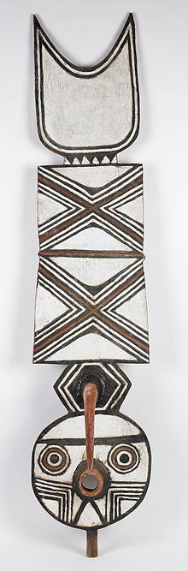



Plank mask with symbolic geometric motifs. [Birmingham Museum of Art](http://en.wikipedia.org/wiki/Birmingham_Museum_of_Art).

http://www.youtube.com/watch?v=ovAZyo\_Xlh8 (9 minutes)

The Bwa are well known for their use of traditional tribal masks.[[2]](http://en.wikipedia.org/wiki/Bwa_people" \l "cite_note-CDR50-2) The masks, made from wood and leaves, are used in traditional rituals. In particular the Southern Bwa are known for their tall plank masks, known as *nwantantay*, and tend to use wood to make their masks.[[2]](http://en.wikipedia.org/wiki/Bwa_people" \l "cite_note-CDR50-2)[[3]](http://en.wikipedia.org/wiki/Bwa_people" \l "cite_note-FAA-3) [[1]](http://www.uiowa.edu/~africart/Dossi mask gallery/index.htm) This is a result of their adoption of Nuna religion and their traditions of using wooden masks.[[2]](http://en.wikipedia.org/wiki/Bwa_people" \l "cite_note-CDR50-2) About 1897, after a series of disasters, including the arrival of the French and their Senegalese mercenaries, the Bwa decided God had abandoned them, so they turned to their Nuna neighbors and purchased the rights to use, wear, and carve wooden masks, their costumes, and the songs and dances that go with them. The religion associated with wooden masks is focused on the spirit Lanle, whose power is manifested through the wooden masks. The northern Bwa use leaf masks more than wooden ones.[[3]](http://en.wikipedia.org/wiki/Bwa_people" \l "cite_note-FAA-3) [[2]](http://www.uiowa.edu/~africart/Leaf masks web/index.htm) These leaf masks frequently represent Dwo in religious ceremonies.[[7]](http://en.wikipedia.org/wiki/Bwa_people" \l "cite_note-CDR53-7) The masks also represent the bush spirits including [serpents](http://en.wikipedia.org/wiki/Snake), [monkeys](http://en.wikipedia.org/wiki/Monkey), [buffalo](http://en.wikipedia.org/wiki/Water_Buffalo) and [hawks](http://en.wikipedia.org/wiki/Hawk).[[3]](http://en.wikipedia.org/wiki/Bwa_people" \l "cite_note-FAA-3) Mask performances generally take place in the dry season between February and May.[[2]](http://en.wikipedia.org/wiki/Bwa_people" \l "cite_note-CDR50-2)

Leaf Masks:

Do is also represented by masks bieni, made exclusively of wild plants (stalks, grass, and leaves), because they must not resemble the creations of man.

Leaf masks are made of wild vines that are wrapped around the body tightly enough that the costume will not slip, but loosely enough that the performer's movements will not be restricted. To this wrapping of vines are bound small bundles of green leaves so that every inch of the human body is concealed. A crest of dried grasses called bwosonu (Loudetia togoensis) is bound to the head, or in some villages may be made of white "eagle" feathers gathered in the bush .

Wooden Masks:

Bwa wooden masks represent a number of characters in the myths of their families and clans. Masks represent numerous animals including the antelope, bush buffalo, monkey, and bush pig. Water-dwellers include the [crocodile](http://www.uiowa.edu/~africart/Photos for BF web/Bwa5.jpg), and fish of several types. The serpent, and insects including the butterfly appear, as do birds including hawks and vultures.

The bird masks and butterflies are the most abstract, consisting of a broad, horizontal plank, decorated with large concentric patterns. The mouth projects from the center and there is a large hook representing the hawk's beak or circles representing the patterns on the butterfly's wings.

**The elders of the Kambi clan in Dossi call the masks with broad white wings duho, which means hawk, or Duba which means vulture.** These do not represent butterflies, as has been erroneously reported by J.-L. Paudrat (Huet 1978: 103). Butterfly masks, called yehoti in Boni, have eight enormous target patterns spread across their wings.

Bwa masks are face masks, worn attached to a fiber costume that covers the head. The performer bites hard on a thick fiber rope that passes through holes in the mask, and so secures the mask to his face. Bwa masks, especially the plank masks, tend to be two-dimensional, and do not extend to the back of the head. The fiber costumes worn with masks are traditionally either red or black. Red is much more common and the Bwa have begun to use bright European dyes to produce green, yellow, and purple fiber collars or mantles to be worn with red shirts and trousers.

Hammarström, Harald; Forkel, Robert; Haspelmath, Martin; Bank, Sebastian, eds. (2016). [*"Bwamu"*](http://glottolog.org/resource/languoid/id/bwam1247). [*Glottolog 2.7*](https://en.wikipedia.org/wiki/Glottolog). Jena: Max Planck Institute for the Science of Human History.

1. Hammarström, Harald; Forkel, Robert; Haspelmath, Martin; Bank, Sebastian, eds. (2016). [*"Bwamu"*](http://glottolog.org/resource/languoid/id/bwam1247). [*Glottolog 2.7*](https://en.wikipedia.org/wiki/Glottolog). Jena: Max Planck Institute for the Science of Human History. [↑](#footnote-ref-2)